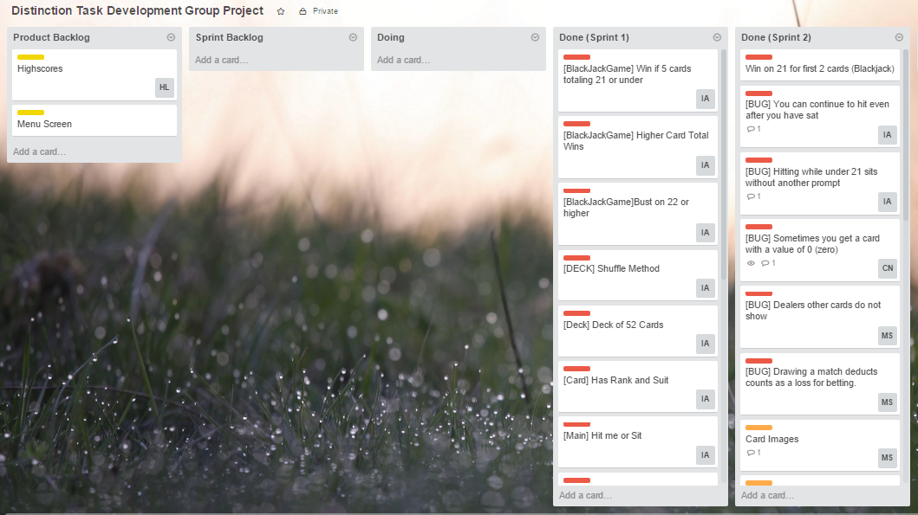**BlackJack Acceptance Test 3 and Sprint 2 Review**

|  |  |
| --- | --- |
| Test | Pass / Fail |
| I should be able to specify how much money to bet initially | **Pass** |
| I should be dealt 2 cards and the dealer 1 | **Pass** |
| I should be able to see the totals of each hand as each card is dealt | **Pass** |
| I should win immediately if my 2 cards total 21, paying out 1.5 times the bet | **Pass** |
| I should have options for ‘hit me’ and ‘sit’ | **Pass** |
| I must bust on 22 or more | **Pass** |
| I should win if I get 5 cards totalling 21 or less | **Pass** |
| I should have an option to double down on the first 2 or 3 cards, giving me one more card | **Pass** |
| The dealer should continue to pick up cards until their total is 16 or higher | **Pass** |
| I should be presented with options to play again or quit | **Pass** |